Fault-Tolerant Wormhole Routing in Mesh with Overlapped Solid Fault Regions
- Seong-Pyo Kim, and Taisook Han
Parallel Computing, Vol. 23, pp. 1937-1962, 1997
Abstract
The proposed algorithm is based on the solid fault model and allows the fault polygons to be overlapped.
- Introduction
We propose a fault-tolerant wormhole routing algorithm in a 2D mesh that can tolerant any number of overlapped fault rings and fault chains based on the solid fault model.
- 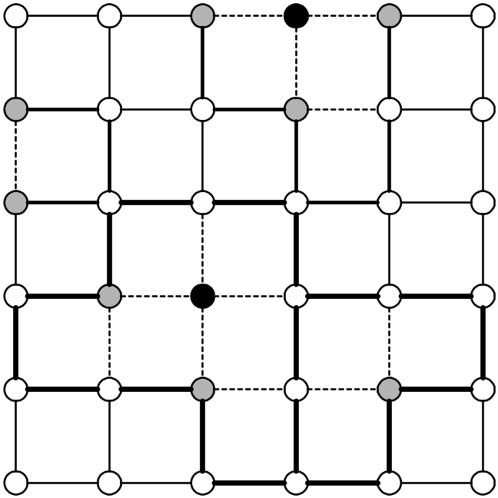Preliminaries
F₁
F₃
F₄
F₂
Faulty node
Concave node node
Fig. 1. Example of the concave nodes and solid fault regions.
- Making solid fault region

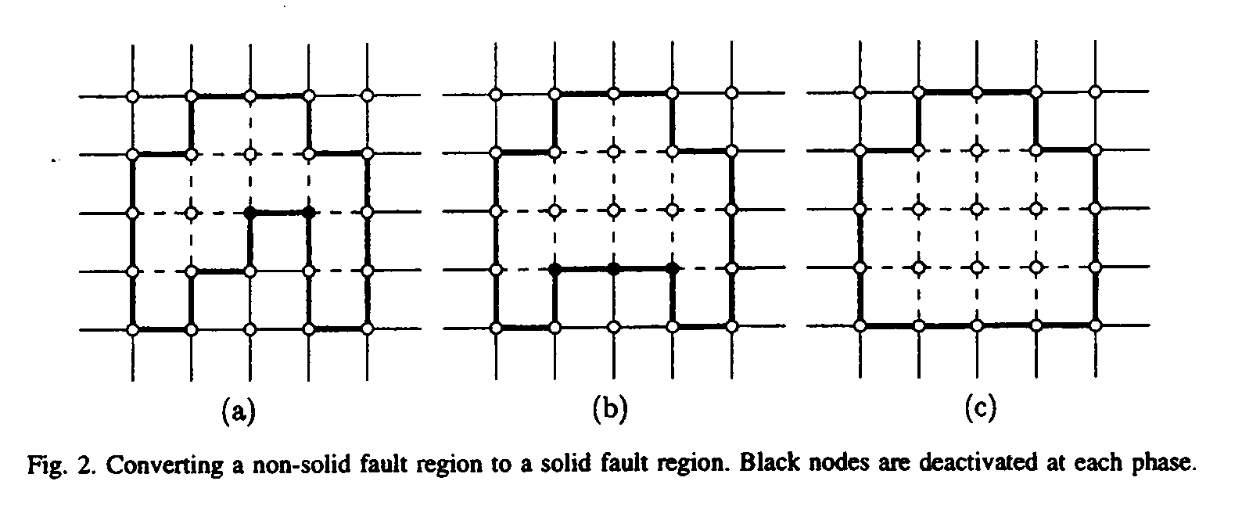

- Fault tolerant routing algorithm in a 2D mesh
Messages are routed by the e-cube algorithm in the fault-free region.

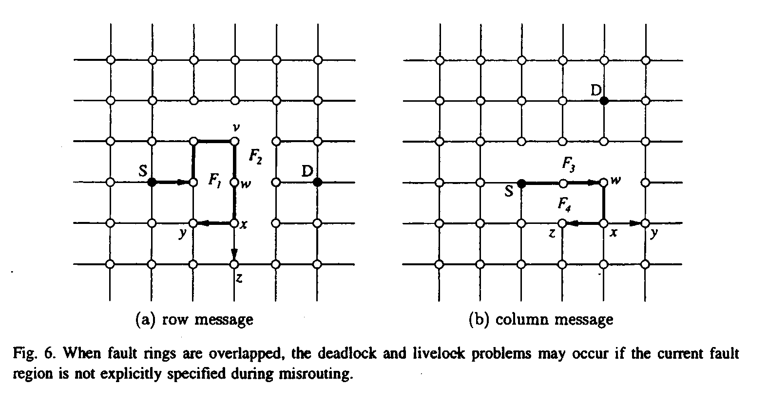

The misrouting direction and the fault direction determination rules:

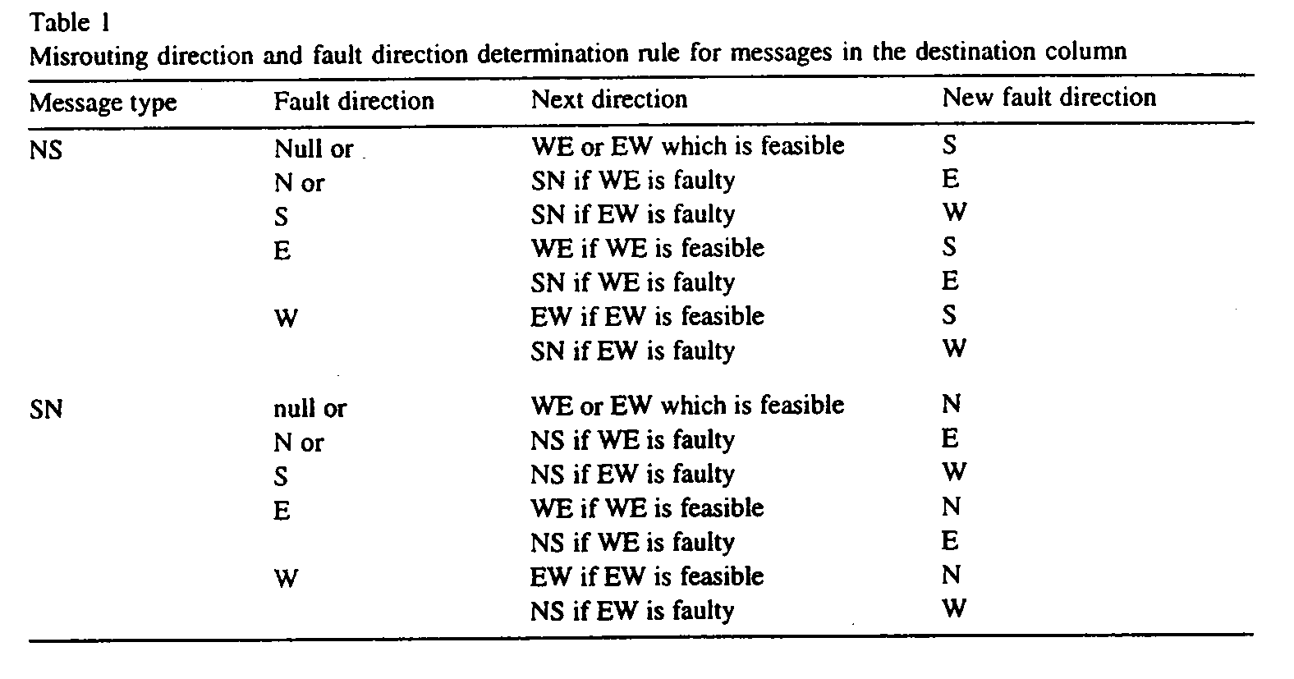

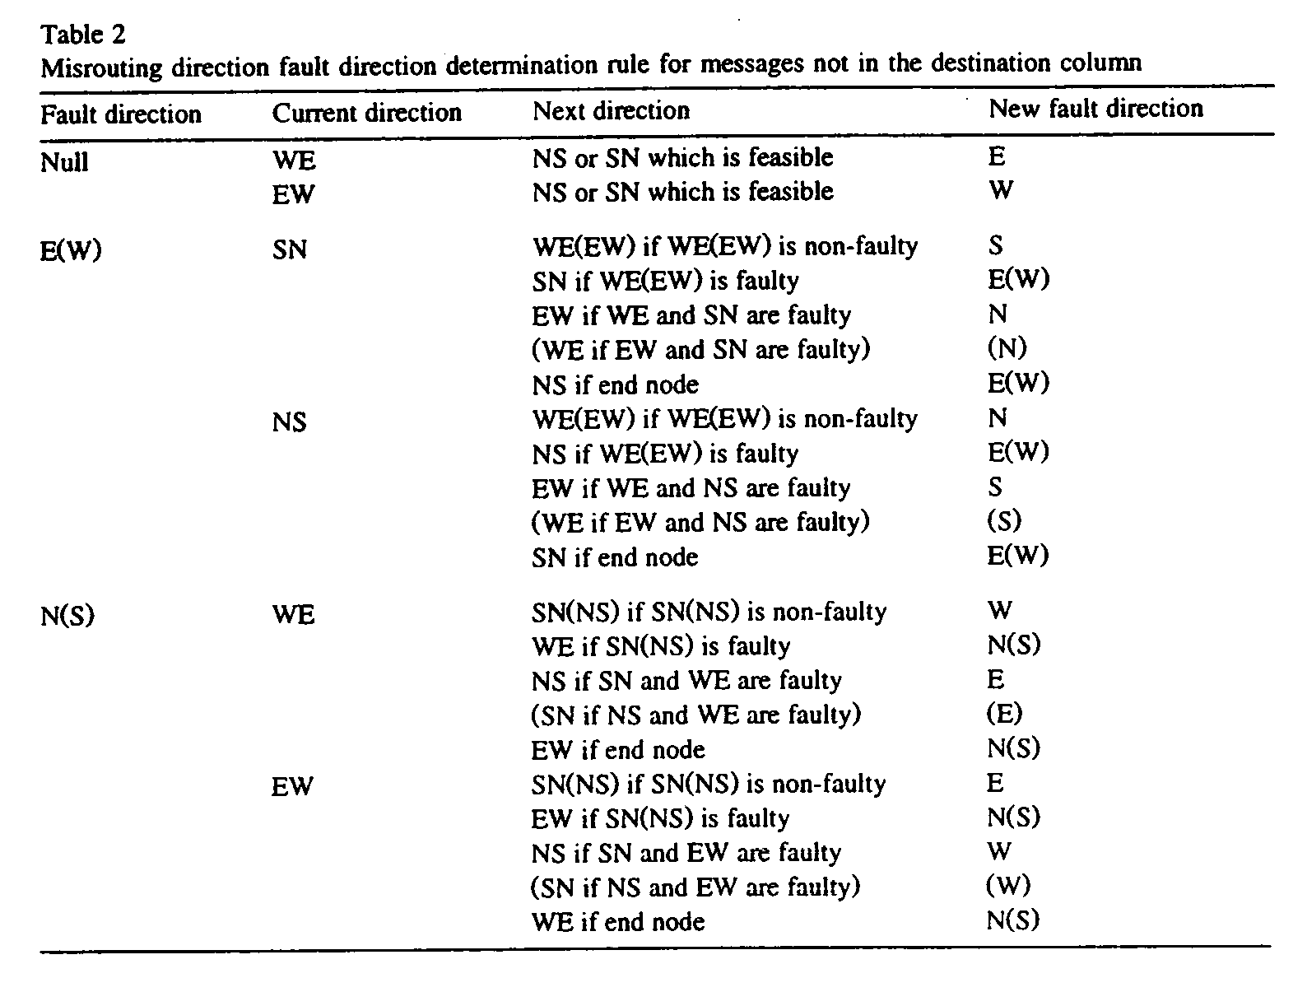

Example: (Fig. 9)
- node (2, 0) to node (7, 5)
- node (7, 9) to node (3, 8)
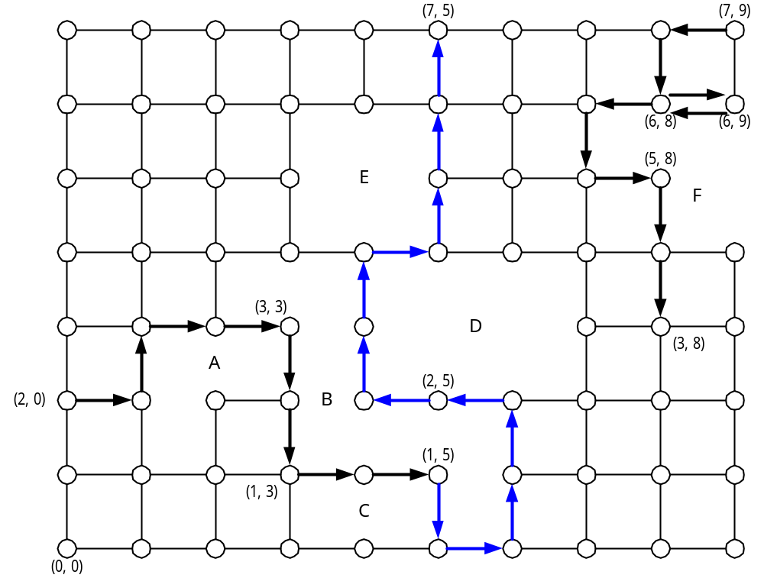
Fig. 9. Example of fault-tolerant routing in 2D mesh.
- Extension to n-dimension meshes
We combine our fault-tolerant routing algorithm with the planar adaptive routing (PAR). A fault region in an n-dimension mesh is solid if its 2D cross section are solid in the (i, i+1)-submeshes, for 0 ≤ i ≤ n-1.

- Concluding remarks
The proposed algorithm guarantees the deadlock- and livelock-free routing in faulty meshes even with the overlapped fault regions. The proposed algorithm can handle any number of solid fault regions if the network is not disconnected by faulty components and uses only local fault information.

Created by : Chia-Hao Yang
Date : June 3, 1998

